NoSQL databases
- NoSQL databases
- Relational Databases pro’s and con’s
- In a relational database, every table has a schema.
- Every column has a pre-defined size and data type.
- Each row in the table must conform the table design.
- Tables are related to each other using foreign keys
- Data duplication is eliminated
- One piece of information is ideally stored once in the database
一条信息理想地存储在数据库中
- If a piece of data changes, then ideally it only needs to be changed once. 如果一段数据发生了变化，那么理想情况下它只需要更改一次。
- We can use SQL to search for / retrieve data
- However,
- not good with “big” data
- not good with distributed (partitioned) databases
不适合使用分布式(分区)数据库
- Problem "Big Data"
- Data that exist in very large volumes and many different varieties (data types) and that need to be processed at a very high velocity (speed)
存在大量数据和许多不同种类(数据类型)，需要以非常快的速度处理的数据。
- VOLUME – much larger quantity of data than traditional relational databases
- VARIETY – lots of different data types and formats
- VELOCTY – data is coming in at a very fast rate (e.g. mobile sensors, data click streams)
- Adoption of NoSQL is driven by “cons” of Relational databases
NoSQL的采用是由关系数据库的“缺点”所驱动的
- Relational DBMS will not go away
- Big Data – characteristics
- Schema on Read, rather than Schema on Write
- Schema on Write – preexisting data model, how traditional databases are designed (relational databases)
写上的模式——预先存在的数据模型，传统数据库的设计方式(关系数据库)
- Schema on Read – data model determined later, depends on how you want to use it (XML, JSON)
- Capture and store the data捕获并存储数据
- worry about how you want to use it later
- Problem “Distributed data”
- Distributed, especially partitioned, databases are not a good fit for some relational features, e.g. foreign keys and transactions.
分布式数据库，特别是分区数据库，不适合一些关系特性，例如外键和事务。
- Foreign keys may be stored in remote locations
- Network latency – creates bottle necks for resources
网络延迟——为资源创建瓶颈
- Non Relational Databases
- A NoSQL database is a non-relational database
- There are different types of NoSQL databases. E.g.
- Key-value stores such as Redis, Azure Table Storage
- Column-based stores like Cassandra, Druid
- Graph databases like NEO4, AllegroGraph, ArangoDB
- Document databases like MongoDB, Azure Cosmos DB.
- Document Databases
- A document is NOT a word processing document! It is NOT a .pdf document or a spreadsheet!
- A document database stores entities as documents, meaning JSON (pronounced Jason) documents
- JSON documents are similar to XML files.
- Types of NoSQL: key-value store
- Key = primary key
- Value = anything (number, array, image, JSON)
- No query language
- The application is in charge of interpreting what it means.
应用程序负责解释它的含义。
- Popular application - recording sessions in applications that require logins. Data about each session (period from login to logoff) is recorded in a key-value store. Sessions are marked with identifiers and all data recorded about each session (e.g. client IP address, profile, credit card (if transaction), etc). 流行的应用程序——在需要登录的应用程序中记录会话。关于每个会话(从登录到注销的时间段)的数据记录在一个键值存储中。会话用标识符标记，并且记录关于每个会话的所有数据(例如，客户IP地址、配置文件、信用卡(如果是交易)等)。
- Session details on shopping (adding items to shopping carts). Note, RDBMS are more suitable to storing payment details.
关于购物的会话细节(向购物车添加物品)。注意，RDBMS更适合存储支付细节。
- Key names can range from a simple number to specific descriptions of the value in the Value field.
键名的范围从简单的数字到value字段中值的具体描述。
- Can be compared to a Dictionary where words are keys and their explanations are values.
- Riak, Redis, Memcached, Berkeley DB, Project Voldemort, Couchbase
- Types of NoSQL: column family
- “Column family” or “wide-column” is like a relational table.
- It contains many “rows”.
- But each row can store a different set of columns.
- Columns rather than rows are stored together on disk.
列而不是行一起存储在磁盘上。
- Makes analysis by column faster– not for OLTP.
- Examples: Cassandra, BigTable, HBase, DynamoDB
- Aggregate-oriented databases
- Key-value, document store and column-family are “aggregate-oriented” databases (in Fowler’s terminology)
键值、文档存储和列族是“面向聚合”的数据库(用Fowler的术语来说)
- Pros
- entire aggregate of data is stored together整个数据集合被存储在一起
- less need for transactions
- efficient storage on clusters / distributed databases
集群/分布式数据库上的高效存储
- Cons
- hard to analyse across subfields of aggregates e.g. sum over products instead of orders
很难分析聚合的各个子领域，例如产品的总和而不是订单
- Graphs
- A data structure consisting of nodes/vertices and ties/edges/arcs
一种由节点/顶点和结/边/弧组成的数据结构
- Nodes/vertices represent entities
- Arcs/ties/edges represent relationships
- May be directed or undirected
- In a graph database:
- nodes and ties can have properties and types
节点和纽带可以具有属性和类型
- the emphasis is on relationships
- connected nodes physically “point” to each other in the database
在数据库中，连接的节点在物理上相互“指向”
- Practical examples:
- Passing messages on social media (who talks to whom)
- Road networks
- Networked devices
- Geo-spatial data (e.g. volcanoes) 地理空间数据(例如火山)
- Types of NoSQL: graph database
- A ‘graph' is a node-and-tie network
- Graphs are difficult to program in relational DB
- A graph DB stores entities and their relationships
- Graph queries deduce knowledge from the graph using node relationships图查询使用节点关系从图中推断知识
- Often used with OLTP databases/systems
- Examples: Neo4J, Infinite, Graph, OrientDB, FlockDB, TAO
- The Neo4J graph database
- Nodes
- Movie, Actor, Director, User, Genre are the labels used in this example.
- Relationships
- ACTED_IN, IN_GENRE, DIRECTED, RATED are the relationships used in this example.
- Properties属性
- title, name, year, rating are some of the properties used in this example.
- Neo4J queries
- Queries are written in the Cypher language
- 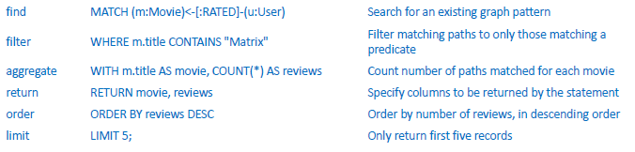
- 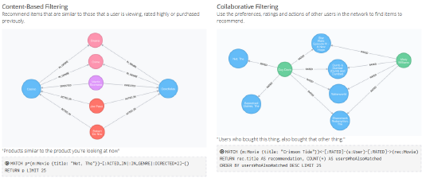
- Types of NoSQL: document database 最重要
- Like a key-value database, except that the "value" (document) is "examinable" by the database, so its contents can be queried and updated类似于键值数据库，只是“值”(文档)可以被数据库“检查”，所以它的内容可以查询和更新
- document = object represented by JSON
- Examples: MongoDB, CouchDB, Terrastore, OrientDB, RavenDB
- ACID vs BASE -期末考试要考
- ACID (Atomic, Consistent, Isolated, Durable) 原子，一致，隔离，耐用
- BASE (Basically Available, Soft state, Eventual consistency)
- Basically Available: This constraint states that the system does guarantee the availability of the data; there will be a response to any request. But data may be in an inconsistent or changing state.
基本可用:该约束表示系统确实保证了数据的可用性;对任何请求都会有回应。但数据可能处于不一致或不断变化的状态。
- Soft state: The state of the system could change over time - even during times without input there may be changes going on due to ‘eventual consistency’.
软状态:系统的状态可能会随着时间而变化——即使在没有输入的时候，也可能会由于“最终一致性”而发生变化。
- Eventual consistency: The system will eventually become consistent once it stops receiving input. The data will propagate to everywhere it needs to, sooner or later, but the system will continue to receive input and is not checking the consistency of every transaction before it moves onto the next one.
最终一致性:一旦停止接收输入，系统将最终保持一致。数据迟早会传播到它需要的任何地方，但是系统将继续接收输入，并且在进入下一个事务之前不会检查每个事务的一致性。
- Document DB: Replication and Consistency多复制一致性
- RDBMS: Often a single copy of the database. You wouldn't expect that a bank customer has multiple versions of his/her bank balance throughout multiple databases.
通常是数据库的单一副本。您不会期望银行客户在多个数据库中拥有他/她的银行余额的多个版本。
- NoSQL Document DB: are often replicated. This allows them to satisfy high volume of queries and searches. Processes in place for changes to a document to be propagated to multiple replicas of the database.
NoSQL Document DB:经常被复制。这使得他们能够满足大量的查询和搜索。处理将文档更改传播到数据库的多个副本的适当过程。
- RDBMS: Enforce strong consistency.
- After data is updated, every user sees new updated values immediately
- E.g. no-one should see an out of date value of the customers bank balance! 没有人应该看到过期的价值客户的银行余额!
- DocumentDB: Eventual consistency最终一致性
- After data is updated (e.g. customer address)
- changes are made in multiple documents (that store the address)
- changes are propagated through multiple replicated databases
更改通过多个复制的数据库传播
- All data is eventually updated.
- Does it matter if not everyone can see absolutely latest comment?
如果不是每个人都能看到绝对最新的评论，这有关系吗?
- JSON
- JSON documents
- JavaScript Object Notation (pronounced Jason)
- represents a (JavaScript)v object and its properties
表示一个(JavaScript)v对象及其属性
- An object consists of a set of attribute-value pairs, including arrays of objects对象由一组属性值对组成，包括对象数组
- has a ‘tree’ structure
- Originally used for transmitting data between computers
- Now the storage format for Document databases
- Not normalised (not even 1NF)
- What is JSON?
- JSON is a syntax for passing around objects that contain
- name/value pairs
- arrays阵列
- other objects.
- 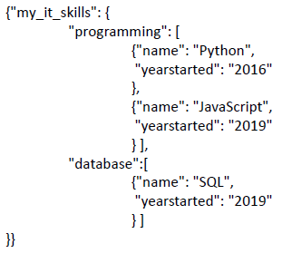
- Curly braces { } act as containers花括号{}充当容器
- Square brackets [ ] hold arrays方括号[]表示数组
- Array elements are separated by commas
- Names and values are separated by a colon
名称和值之间用冒号分隔
- Values surround by double-quotes (in some notations names are also in double quotes)
值用双引号括起来(在某些符号中名称也用双引号括起来)
- Human readable
- Hierarchical (can store values within values)
分层(可以在值中存储值)
- These terms are interchangeable这些术语是可以互换的
- Name – Value pair
- Key – Value pair
- Attribute – Value pair
- Rows vs Documents
- RDBMS: Data is stored in Rows.
- 3 customers requires 3 rows
- NoSQL Document DB: Data is stored in multiple Documents
- 3 customers require 3 documents
- Columns vs Properties列和属性
- RDBMS: Each row consists of multiple Columns
- NoSQL Document DB: Each document consists of multiple Properties
每个文档由多个属性组成
- Documents are schema free
- RDBMS: Each row must conform to the schema
- NoSQL Document DB: Each document may use any properties (name/value pairs) 每个文档可以使用任何属性(名称/值对)
- Document 3 has additional properties for the customer's name
文档3具有客户名称的其他属性
- Each document must have an ID property每个文档必须有一个ID属性
- Document properties are indexed文档属性被索引
- NoSQL Document DB: As each document is added to the database, every property is automatically indexed.
在将每个文档添加到数据库中时，每个属性都会自动建立索引。
- This means that retrieval speeds for any data is very quick
这意味着任何数据的检索速度都非常快
- Normalised vs Denormalised
- RDBMS: Tables have foreign keys to form relationships between tables Tables must be joined when queried. There is performance overhead.
- NoSQL Document DB: Each document is denormalised.
- 'Holdings' data is stored in the same document as customers data.
“控股”数据与客户数据存储在同一文档中。
- Queries are simple to write and fast to execute.
- Fewer Joins.
- Redundant Data冗余数据
- RDBMS: Redundant Data is eliminated
- NoSQL Document DB: Documents contain redundant data
- The description of product "BC" is repeated in many documents
- Parent / Child relationships
- DocumentDB: This document contains a 1:M relationship within a single document
- This is reasonable when there is a limit to the maximum number of comments (children) 当对最大评论数(孩子)有限制时，这是合理的。
- It is impractical to attempt to store an infinite number of children in a single document试图在单个文档中存储无限多的子元素是不切实际的
- 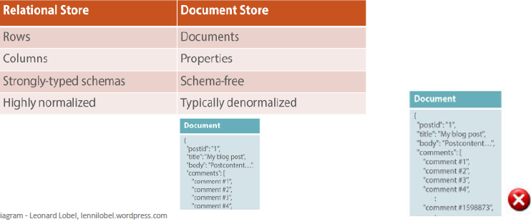
- Documents can be normalized
- NoSQL Document DB: The design of documents is flexible
- You may choose to create a 1:M relationship between documents
- Here comments are stored as separate documents
- Combine aspects of normalised and denormalised
- DocumentDB: This design stores multiple 100 comments (children) per document此设计为每个文档存储多个100条注释(子注释)
- Nested Objects
- A JSON document can contain properties, arrays and objects
- Manipulating data in a NoSQL database操作NoSQL数据库中的数据
- Data in NoSQL document databases is manipulated using JSON
NoSQL文档数据库中的数据使用JSON进行操作
- E.g. db.<collection>.find() in MongoDB is equivalent to SELECT … FROM <table> – Replace <collection> with the actual collection name
- NoSQL databases have “browsers”, e.g.
- Compass for MongoDB was developed by MongoDB developers
MongoDB Compass是由MongoDB开发者开发的
- Studio 3T for MongoDB developed by 3rd party
MongoDB的Studio 3T由第三方开发
- NoSQLbooster for MongoDB developed by 3rd party
NoSQLbooster for MongoDB由第三方开发
- Some browsers can translate SQL into JSON

Distributed Databases
- Definitions
- Distributed Database
- a single logical database physically spread across multiple computers in multiple locations that are connected by a data communications link
- appears to users as though it is one database
对用户来说，它似乎是一个数据库
- Decentralized Database
- a collection of independent databases which are not networked together as one logical database
- appears to users as many databases
- Database Memory Structure (1 Server)
- 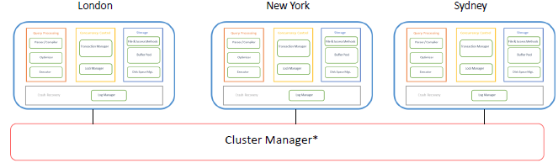
- Each Physical Server has one of these memory structures
- Often accessing their own and shared physical storage between all physical servers经常访问所有物理服务器之间自己的和共享的物理存储
- Cluster Manager coordinates communication between physical servers
集群管理器负责协调物理服务器之间的通信
- Distributed DBMS Advantages
- Good fit for geographically distributed organisations / users
- Utilize the internet
- Data located near site with greatest demand
- ESPN Weekend Sports Scores
- 
- Faster data access (to local data)
- Faster data processing
- workload is shared between each physical server
工作负载在每个物理服务器之间共享
- 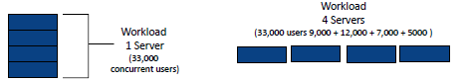
- Allows modular growth
- Add new servers as load increases
- 
- Increased reliability and availability
- Lower danger of a single-point of failure (SPOF)
降低单点故障(SPOF)的危险
- 
- Supports database recovery
- Data is replicated across multiple sites
- Recovery Logs replicated
- 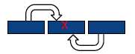
- Disadvantages
- Complexity of management and control
- database or/and application must stitch together data across sites
数据库或/和应用程序必须跨站点缝合数据
- What is the current version of the record (row and column) and where is it?
- Who is waiting to update that information and where are they?
- How does the logic display this to the web and application server?
- Data integrity数据完整性
- additional exposure to improper updating不适当更新的额外暴露
- If two users in two locations update the record at the exact same time who decides which statement should “win”?
- Solution: Transaction Manager or Master-slave design
事务管理器或主从设计
- Security
- many server sites -> higher chance of breach
- Multiple access sites require protection from both cyber and physical attacks (including protection of network and storage infrastructure) 多个访问站点需要免受网络和物理攻击的保护(包括网络和存储基础设施的保护)
- Lack of standards
- different Relational DDBMS vendors use different protocols
- Increased training and maintenance costs
- more complex IT infrastructure
- Increased Disk storage ($)
- Fast intra and inter network infrastructure ($$$)
- Clustering software ($$$$)软件聚集
- Network Speed ($$$$$)
- Increased storage requirements
- Replication model
- Objectives and Trade-offs
- Location transparency
- a user does not need to know where particular data are stored
- A user (or program) accessing data do not need to know the location of the data in the network of DBMS’s
- Requests to retrieve or update data from any site are automatically forwarded by the system to the site or sites related to the processing request
从任何站点检索或更新数据的请求由系统自动转发到与处理请求相关的站点
- All data in the network appears to users as a single logical database stored at one site
- A single query can join data from tables in multiple sites
- 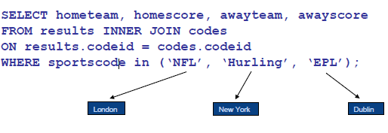
- Local autonomy分布式的特征
- a node can continue to function for local users if connectivity to the network is lost如果网络连接丢失，节点可以继续为本地用户工作
- Users can administer their local database
- control local data
- administer security
- log transactions
- recover when local failures occur
- provide full access to local data
- Being able to operate locally when connections to other databases fail
能够在连接到其他数据库失败时进行本地操作
- Trade-offs
- Availability vs Consistency
- Synchronous vs Asynchronous updates同步更新vs异步更新
- Distributed Options
- Distribution options
- Data replication
- Data copied across sites跨站点复制的数据
- Horizontal partitioning水平分区
- Table rows distributed across sites跨站点分布的表行
- Vertical partitioning
- Table columns distributed across sites
- Replication – advantages
- High reliability due to redundant copies of data
- Fast access to data at the location where it is most accessed
在数据访问最频繁的位置快速访问数据
- May avoid complicated distributed integrity routines
可以避免复杂的分布式完整性例程
- replicated data is refreshed at scheduled intervals
- Decoupled nodes don’t affect data availability解耦的节点不会影响数据可用性
- transactions proceed even if some nodes are down
- Reduced network traffic at prime time
- if updates can be delayed
- Replication – disadvantages
- Need more storage space
- Each server stores a copy of the row
- Data Integrity:
- retrieve incorrect data if updates have not arrived
如果更新尚未到达，则检索不正确的数据
- 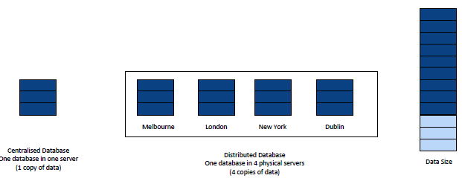
- Takes time for update operations
- High tolerance for out-of-date data may be required
- Updates may cause performance problems for busy nodes
更新可能会导致繁忙节点的性能问题
- Network communication capabilities
- Updates can place heavy demand on telecommunications/networks
- Cost high speed networks are expensive ($$$$$)
- Synchronous updates同步更新
- Data is continuously kept up to date
- Users anywhere can access data and get the same answer.
- If any copy of a data item is updated anywhere on the network, the same update is immediately applied to all other copies or the update is aborted.
- Ensures data integrity and minimises the complexity of knowing where the most recent copy of data is located.
- Can result in slow response time and high network usage
- The DDBMS spends time checking that an update is accurately and completely propagated across the network.
DDBMS花时间检查更新是否在网络上准确而完整地传播。
- The committed updated record must be identical in all servers
- Asynchronous updates
- Some delay in propagating data updates to remote databases
将数据更新传播到远程数据库时的一些延迟
- Some degree of at least temporary inconsistency is tolerated
- May be ok if it is temporary and well managed
- Acceptable response time
- Updates happen locally and data replicas are synchronized in batches and predetermined intervals
更新发生在本地，数据副本以预先确定的间隔批量同步
- May be more complex to plan and design
- Need to ensure the right level of data integrity and consistency
- Suits some information systems more than others
- Compare commerce/finance systems with social media
- Horizontal partitioning
- Different rows of a table at different sites
- Advantages
- data stored close to where it is used– efficiency
- local access optimization– better performance
- only relevant data is stored locally– security
- unions across partitions– ease of query跨分区的联合-易于查询
- Disadvantages
- accessing data across partitions– inconsistent access speed
跨分区访问数据—访问速度不一致
- no data replication– backup vulnerability (SPOF)
- Example horizontal partitioning
- 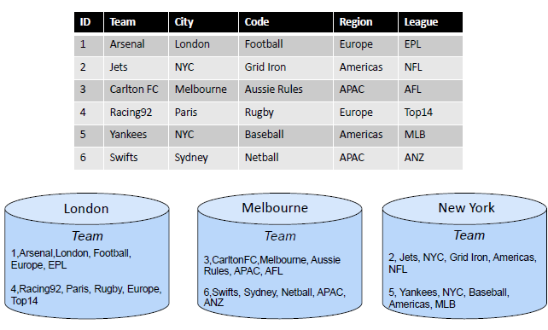
- Vertical partitioning
- Different columns of a table at different sites
- Advantages and disadvantages are the same as for horizontal partitioning
- Except
- combining data across partitions is more difficult because it requires joins (instead of unions)
- 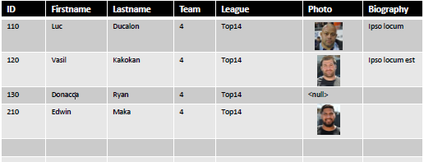
- 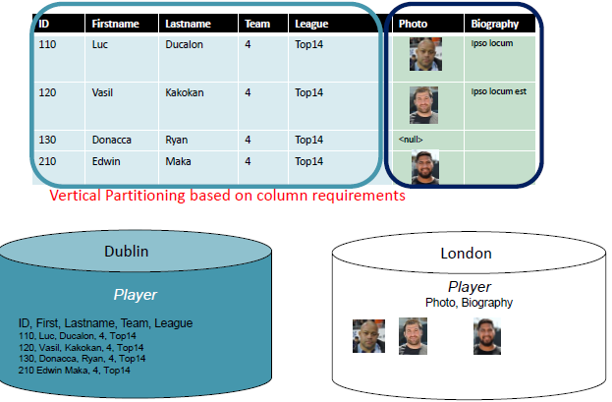
- Comparing 5 configurations
- Centralised database, distributed access
- DB is at one location, and accessed from everywhere
- Replication with periodic (asynchronous) snapshot update
- Many locations, each data copy updated periodically
- Replication with near real-time synchronization of updates
- Many locations, each data copy updated in near real time
- Partitioned, integrated, one logical database
- Data partitioned across many sites, within a logical database, and a single DBMS
- Partitioned, independent, non-integrated segments
- Data partitioned across many sites. 跨多个站点分区的数据
- Independent, non-integrated segments
- Multiple DBMS, multiple computers
- Functions of a distributed DBMS
- Locate data with a distributed catalog (meta data)
- Determine location from which to retrieve data and process query components确定从何处检索数据和处理查询组件的位置
- DBMS translation between nodes with different local DBMSs (using middleware)
- Data consistency (via multiphase commit protocols)
数据一致性(通过多阶段提交协议)
- Global primary key control
- Scalability可扩展性
- Security, concurrency, query optimisation, failure recovery
- Distributed DBMS architecture
- Network partitions网络分区
- Imagine you have a synchronously-updating, replicated database
- Now imagine that the link between 2 nodes is interrupted
现在假设两个节点之间的链路中断了
- What are your choices?
- shut down the system (to avoid inconsistency)
- keep it available to users (and accept inconsistency)

